ARTICLE LAYOUT TEMPLATE

DOI:
UDC 338.45:621-047.44(477)

Name SURNAME
Scientific degree, Academic status, Position, Department
Institution,
City, Country
ORCID ID:
Scopus Author ID:

title of the article

Анотація. Text of abstract in Ukrainian
Ключові слова: Keywords in Ukrainian.

JEL Classification: D24, L90

Absztrakt.. Text of abstract in Hungarian
Kulcsszavak: Keywords in Hungarian.

Abstract. An abstract is a summary of the main article. Essentially the goal of the abstract is to give a one or two sentence summary from each section of the article, which typically contains an introduction or statement of the problem, methods or methodology, results, discussion and conclusions. This section must contain at least 1800 characters.
Key words: 5-8 keywords that describe the content of the article.

Problem statement. Text of statement…
It is a clear, concise, and specific statement that describes the issue or problem that the researcher addresses. It should provide general information about the problem under study and its rationale; explain why the problem is important and what gap in current knowledge or understanding it fills.
Literature review. This section should contain analysis of the most relevant studies and publications, which initiated the solution of this problem and on which the author relies, highlighting previously unresolved parts of the general problem, which is the research object of the given article. This section may provide an overview of the contemporary scientists’ theoretical concepts and principles that underlie the research.
Research aim and objectives. Please, specify the goals of the article, f. e.: The aim of the study is ….
Results and discussions. This section is aimed at achieving the research objectives. Here should be presentation of the main material of the study with a full justification of the obtained scientific results.
Examples of formatting graphic materials (tables, pictures, graphs etc):
Table 1 - Dynamics of manufactured cars in Ukraine in 2016-2021, units*
Types of cars | Years |  |  |  |  |  | Deviation 2020/2016
 | 2016 | 2017 | 2018 | 2019 | 2020 | 2021 | +/- | %
Passenger Cars | 4340 | 7296 | 5660 | 6254 | 4202 | 7342 | +3002 | +69
Commercial Vehicles (CV) | 123 | 486 | 132 | 136 | 51 | 35 | -88 | -72
TOTAL | 4463 | 7782 | 5792 | 6390 | 4253 | 7377 | +2914 | +65
* Retrieved from: [3, 4]

Fig. 1. Dynamics of manufactured cars in Ukraine in 2016-2021, units

Table 2 - Structure of passenger car production by major manufacturers in Ukraine in 2016-2021*
 | Years |  |  |  |  |  | 2021/2016
 | 2016 | 2017 | 2018 | 2019 | 2020 | 2021 | +/- | %
JSC "ZAZ" (Zaporizhia Automobile Building Plant) | 521 | 1630 | 86 | 15 | 816 | 3866 | 3345 | 642,0%
Share in total, % | 11,7% | 20,9% | 1,5% | 0,2% | 19,2% | 52,4% | 40,7% | -
PrJSC "EUROCAR" | 3937 | 6145 | 5659 | 6254 | 3386 | 3476 | -461 | -11,7%
Share in total, % | 88,2% | 79,0% | 97,7% | 97,9% | 79,6% | 47,1% | -41,1% | -
PJSC "Cherkassy Bus" | 5 | 7 | 47 | 121 | 51 | 35 | 30 | 600,0%
Share in total, % | 0,1% | 0,1% | 0,8% | 1,9% | 1,2% | 0,5% | 0,4% | -
TOTAL | 4463 | 7782 | 5792 | 6390 | 4253 | 7377 | 2914 | 65,3%
* Retrieved from: [3]

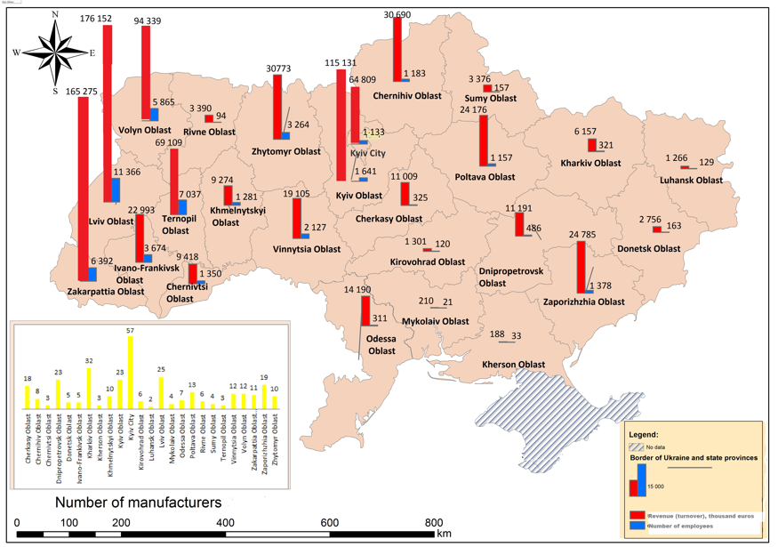
Fig. 2. Allocation of car component manufacturers by regions of Ukraine in 2020.

Conclusions and prospects for further research. The conclusion of a research paper should have several key elements: a restatement of the research problem; a summary of your key arguments and/or findings; a short discussion of the implications of your research. The author also ought to outline and give recommendations for future research in the given area.

REFERENCES
- Savelyev Y., Kuryliak V., Darvidou K., Lyzun M., Lishchynskyy I. (2021) Transformation of Ukrainian Automotive Industry in the Context of Electromobility: Applying the Experience of Visegrad States. IV International Scientific Congress “Society of Ambient Intelligence – 2021” (ISCSAI 2021). SHS Web Conf., Volume 100. https://doi.org/10.1051/shsconf/202110001018
- International Organization of Motor Vehicle Manufacturers. Production statistic. https://www.oica.net/production-statistics/ (last accessed: 26.05.2022)

