**REQUIREMENTS FOR PUBLICATION FOR THE SCIENTIFIC JOURNAL**

**"ACTA ACADEMIAE BEREGSASIENSIS. ECONOMICS"**

Scientific publication "**Acta Academiae Beregsasiensis. Economics**" is intended for specialists who are interested in theoretical and applied problems of economics, management, finance, accounting, taxation, analysis and auditing, enables the scientific community to be acquainted with the research results of scientists and practitioners.

**The main thematic areas of the scientific journal are:**

– Economics;

– Accounting and taxation (accounting, taxation, control, analysis, audit);

– Finance, banking, insurance and stock market;

- Management.

**The scientific journal is a peer-reviewed publication that supports the policy of open access to scientific publications.**

*The editorial board supports world standards of transparency of the review process; accordingly, the manuscript passes through*:

- Check for plagiarism. The editorial board using the Unicheck system checks the existence of coincidences, identities or similarities in the texts provided by the authors;

- Independent expert review. Manuscripts undergo blind peer review, which is an anonymous manuscript evaluation process where the reviewers do not know who the author of the scientific article is, and the author does not know who the reviewers are.

**GENERAL REQUIREMENTS FOR MANUSCRIPTS LAYOUT**

The manuscripts submitted for consideration by the Scientific Journal “**Acta Academiae Beregsasiensis. Economics**”:

* Should be contemporary, original and independent research that have never been published before and have not been submitted for consideration in other publications;
* Should not contain:
* materials prohibited for printing,
* materials whose authenticity is in doubt,
* inappropriate textual borrowings without valid references (plagiarism), self-plagiarism (large-scale borrowing from one’s own works without providing proper references)

**Language of publications:** Ukrainian, Hungarian, English.

For paper submission in the **Issue 3/2023**, the following materials must be sent by e-mail to the editorial office of the journal ([aab-economics@kmf.org.ua](mailto:aab-economics@kmf.org.ua)) no later than **June 1, 2023**:

1. Information about the author.
2. A scientific manuscript that adhere the specified requirements.
3. Review of a scientific supervisor or other specialist in a certain field of knowledge, who has a relevant scientific degree (submitted only by graduate students and applicants).

The manuscript should include the following components in the following sequence:

1) DOI (assigned by the editors after publication of the article) (pin 13 pt);

2) UDC index (in the upper left corner of the page) (pin 13 pt);

3) Surname and first name of the author(s) (in the next line, in the center, no more than 3 persons) (pin 13 pt);

4) Information about the author (authors), after each author the scientific degree, academic title, position, name of the institution, city, country where the authors work (pin 11 pt);

5) The title of the article (one line from the authors' names in the center, up to 10 words - pin 13 pt, all capital letters, bold font);

6) Structured abstract (abstract) - one line after the title of the article in italics, no less than 1800 characters with spaces (11 pt). (with the use of impersonal constructions, the abstract should contain the following elements (subject, purpose of the work; method or methodology of conducting the work; results of the work; scope of application of the results; conclusions);

7) Key words (5–8 words) (pin 11 pt, italics);

8) submit the information according to the above items 3-7 consecutively in the language of the article, in Ukrainian (if the article is not in Ukrainian) and in English;

9) JEL classification code (placed under keywords, the number is from 1 to 5, in one line, separated by a comma, in bold font. For example: JEL Classification: M10, M30)

10) The text of the article (pin 13 pt) in a structured form with the selection of the following elements (semi-bold italics from the paragraph):

**The structure of an article** should include the following necessary elements (based on the requirements of the Resolution of the Presidium of the HAC of Ukraine of 15.01.2003 №7-05.1):

1. **Problem description.** Statement of the problem in general and its connection with important scientific or practical tasks.
2. **Literature review.** Analysis of recent research and publications, which initiated the solution of this problem and on which the author relies, highlighting previously unresolved parts of the general problem, which is the subject of this article.
3. Formulation of the **goals of the article** (task setting).
4. **Results and discussions.** Presentation of the main material of the study with a full justification of the obtained scientific results.
5. **Conclusions and prospects for further research** in this area.
6. **References**. List of sources used are numbered according to the order of reference in the text. The reference to the source is given in square brackets; bibliographic description of the literature is made in accordance with the National Standard of Ukraine "Bibliographic reference" (DSTU 8302:2015), or the APA style. The number of self-citations should not exceed 20%.

**Manuscript parameters:**

* languages of writing the manuscript - Ukrainian, Hungarian, English;
* number of co-authors - **not more than 3**;
* volume of the manuscript – 4-12 pages, including figures and tables; page format - A4,
* page orientation - "book"; margins: left - 2.5 cm, right - 1.5 cm, top - 2.0 cm, bottom - 2.0 cm;
* font - Times New Roman, 13; line spacing is 1.0.
* the manuscript must be prepared using the Word for Windows® editor as a single file in DOC or DOCX format without macros;
* drawings, photographs, graphics should be inserted into the text of the article as an object, the position of the object - "in the text"; use the Microsoft Equation or Mathtype! formula editor built into Word to set formulas. Physical quantities must be given in SI units;
* tables should not be torn (placed on several pages);
* the abstract to the article should be expanded (1800 characters with spaces).

More detailed information can be found on the official website «**Acta Academiae Beregsasiensis. Economics**» at the following link: <http://www.aab-econ.kmf.org.ua>

**The author's reference in the following form is sent along with the article:**

Information about the author

*(To be filled in separately for each author. The document is submitted electronically as an MS Word file)*

|  |  |
| --- | --- |
| First name |  |
| Surname |  |
| Scientific degree |  |
| Academic status |  |
| Position |  |
| Institution |  |
| City, country |  |
| Scopus Author ID * |  |
| ORCID ID |  |
| Researcher ID* |  |
| MTMT ID* |  |
| Mobile phone number |  |
| E-mail address: |  |

* - if available.

*Note: Availability of an ORCID identifier is a mandatory term for submitting manuscripts. In case of absence the identifier, please register using the following link:* [*https://orcid.org/*](https://orcid.org/)

If there are more than one author, then information should be provided by every author separately.

**ATTENTION!** If you have not received a confirmation letter in more than 10 working days, please, contact the editors again.

**ARTICLE LAYOUT TEMPLATE**

**DOI:**

**UDC** 338.45:621-047.44(477)

**Name SURNAME**

Scientific degree, Academic status, Position, Department

Institution,

City, Country

**ORCID ID:**

**Scopus Author ID:**

**title of the article**

***Анотація.*** *Text of abstract in Ukrainian*

***Ключові слова:*** *Keywords in Ukrainian.*

**JEL Classification:** D24,L90

***Absztrakt.****. Text of abstract in Hungarian*

***Kulcsszavak:*** *Keywords in Hungarian.*

***Abstract****. An abstract is a summary of the main article. Essentially the goal of the abstract is to give a one or two sentence summary****from each section****of the article, which typically contains an introduction or statement of the problem, methods or methodology, results, discussion and conclusions. This section must contain at least 1800 characters.*

***Key words****: 5-8 keywords that describe the content of the article.*

**Problem statement.** Text of statement…

It is a clear, concise, and specific statement that describes the issue or problem that the researcher addresses. It should provide general information about the problem under study and its rationale; explain why the problem is important and what gap in current knowledge or understanding it fills.

**Literature review.** This section should contain analysis of the most relevant studies and publications, which initiated the solution of this problem and on which the author relies, highlighting previously unresolved parts of the general problem, which is the research object of the given article. This section may provide an overview of the contemporary scientists’ theoretical concepts and principles that underlie the research.

**Research aim and objectives.** Please, specify the goals of the article, f. e.:The aim of the study is ….

**Results and discussions.** This section is aimed at achieving the research objectives. Here should be presentation of the main material of the study with a full justification of the obtained scientific results.

Examples of formatting graphic materials (tables, pictures, graphs etc):

**Table 1 - Dynamics of manufactured cars in Ukraine in 2016-2021, units\***

|  |  |  |  |  |  |  |  |  |
| --- | --- | --- | --- | --- | --- | --- | --- | --- |
| **Types of cars** | **Years** | | | | | | **Deviation 2020/2016** | |
| **2016** | **2017** | **2018** | **2019** | **2020** | **2021** | **+/-** | **%** |
| Passenger Cars | 4340 | 7296 | 5660 | 6254 | 4202 | 7342 | +3002 | +69 |
| Commercial Vehicles (CV) | 123 | 486 | 132 | 136 | 51 | 35 | -88 | -72 |
| **TOTAL** | **4463** | **7782** | **5792** | **6390** | **4253** | **7377** | **+2914** | **+65** |

* Retrieved from: [3, 4]

**Fig. 1. Dynamics of manufactured cars in Ukraine in 2016-2021, units**

**Table 2 - Structure of passenger car production by major manufacturers in Ukraine in 2016-2021\***

|  |  |  |  |  |  |  |  |  |
| --- | --- | --- | --- | --- | --- | --- | --- | --- |
|  | **Years** | | | | | | **2021/2016** | |
| **2016** | **2017** | **2018** | **2019** | **2020** | **2021** | **+/-** | **%** |
| JSC "ZAZ" (Zaporizhia Automobile Building Plant) | 521 | 1630 | 86 | 15 | 816 | 3866 | 3345 | 642,0% |
| *Share in total, %* | *11,7%* | *20,9%* | *1,5%* | *0,2%* | *19,2%* | *52,4%* | *40,7%* | *-* |
| PrJSC "EUROCAR" | 3937 | 6145 | 5659 | 6254 | 3386 | 3476 | -461 | -11,7% |
| *Share in total, %* | *88,2%* | *79,0%* | *97,7%* | *97,9%* | *79,6%* | *47,1%* | *-41,1%* | *-* |
| PJSC "Cherkassy Bus" | 5 | 7 | 47 | 121 | 51 | 35 | 30 | 600,0% |
| *Share in total, %* | *0,1%* | *0,1%* | *0,8%* | *1,9%* | *1,2%* | *0,5%* | *0,4%* | *-* |
| **TOTAL** | 4463 | 7782 | 5792 | 6390 | 4253 | 7377 | 2914 | 65,3% |

* Retrieved from: [3]

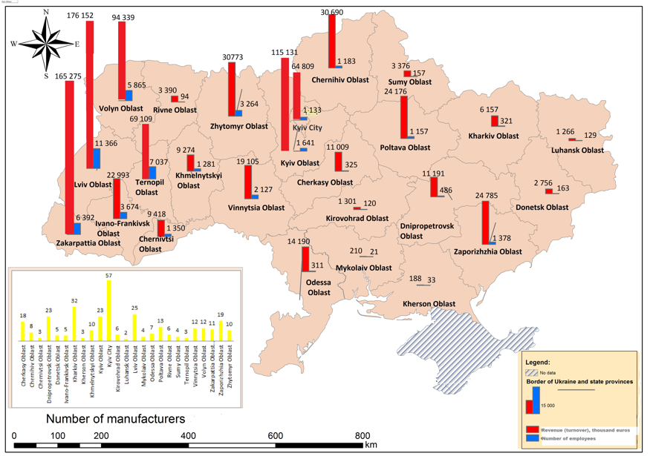

**Fig. 2. Allocation of car component manufacturers by regions of Ukraine in 2020.**

**Conclusions and prospects for further research.** The conclusion of a research paper should have several key elements: a restatement of the research problem; a summary of your key arguments and/or findings; a short discussion of the implications of your research. The author also ought to outline and give recommendations for future research in the given area.

**REFERENCES**

1. Savelyev Y., Kuryliak V., Darvidou K., Lyzun M., Lishchynskyy I. (2021) Transformation of Ukrainian Automotive Industry in the Context of Electromobility: Applying the Experience of Visegrad States*. IV International Scientific Congress “Society of Ambient Intelligence – 2021” (ISCSAI 2021)*. SHS Web Conf., Volume 100. <https://doi.org/10.1051/shsconf/202110001018>
2. International Organization of Motor Vehicle Manufacturers. Production statistic. <https://www.oica.net/production-statistics/> (last accessed: 26.05.2022)